**Telehealth Software Development Proposal**



Prepared by

SURAJ SATISH PAGADE

surajspagade@gmail.com

7972167635

**Introduction**

**A. Overview of Telehealth Software**

Telehealth software is a revolutionary solution that enables healthcare providers to deliver remote medical services, connecting doctors with patients seamlessly.

**B. Significance in Modern Healthcare**

In an era of digital transformation, telehealth software plays a pivotal role in enhancing patient access to healthcare services, improving efficiency, and ensuring timely medical interventions.

**C. Advantages of Implementing Telehealth Software**

1. **Cost-effectiveness**: Reduce operational costs associated with in-person visits.

2**. Improved Patient Outcomes**: Enhance patient engagement and satisfaction.

3. **Accessibility**: Facilitate healthcare services for remote and underserved populations.

**Market Research**

**A. Current Trends in Telehealth**

Recent trends indicate a significant increase in the adoption of telehealth solutions globally, with a focus on video consultations, remote monitoring, and integrated healthcare platforms. New trends such as **Virtual Reality** (VR), **Artificial Intelligence** (AI), and so on are anticipated to further enhance the telemedicine experience by providing immersive and personalized care.

**B. Competitor Analysis & The Future of Tele Healthcare:**

The market of telemedicine in healthcare industry has grown significantly over the past few years. Using telecommunications, it enables healthcare professionals to evaluate, diagnose and treat patients virtually. The telemedicine approach has evolved over the last decade to such an extent that today it is the most integral part of the American healthcare infrastructure. North America is known to be the largest telemedicine market globally and it is envisioned to reach 35 billion dollars by 2025, according to Statista. Analyze key competitors in the telehealth software market, highlighting their features, strengths, and weaknesses to identify opportunities for differentiation.

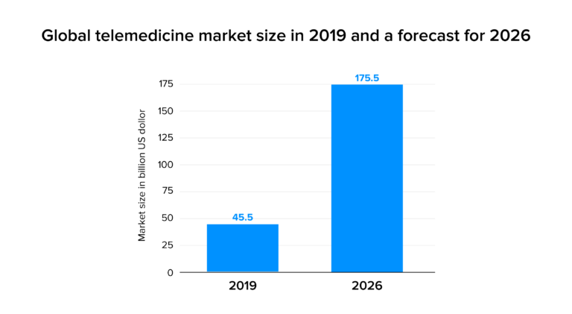

**C. Identifying Unique Selling Points (USPs)**

Define the unique features and benefits that will set our telehealth software apart from competitors, such as user-friendly interface, customizable solutions, and exceptional security measures. Likes,

- HD video chat

- Monitoring system

- Electronic healthcare recording

- Medical device integration

- Wireless communication

- medicine data tracking

- daily diet data

**D. Technology Stack Assessment**

Evaluate and choose the most suitable technologies for development, ensuring scalability, security, and interoperability with existing healthcare systems. It is thus crucial for healthcare leaders to invest in establishing a telehealth performance dashboard that at a minimum includes these 5 critical telehealth metrics:

- Clinician Satisfaction - Patient Satisfaction - Technical Performance - Overall Visit Volume by Modality - Overall Reimbursement by Modality.

**Patient Intake Management**

**A. Online Registration and Profile Creation**

Implement a user-friendly online registration process, allowing patients to create profiles with essential information for efficient healthcare management.

**B. Secure Data Collection**

Utilize robust security measures for the collection and storage of patient data, ensuring compliance with healthcare data protection regulations.

**C. Insurance Verification Integration**

Integrate the software with insurance systems to facilitate seamless and accurate verification, streamlining the billing process.

**D. Electronic Health Records (EHR) Integration**

Ensure compatibility with existing EHR systems, enabling a smooth transition of patient data between platforms.

* Appointment Scheduling
* Automated Appointment Booking
* Reschedule & Cancellation

Provide patients with an intuitive platform for scheduling appointments, minimizing manual intervention and optimizing the booking process.

**Real-time Availability of Doctors**

Implement real-time updates on doctor availability, enabling patients to make informed decisions about their appointments.

**Appointment Reminders**

Incorporate automated reminders to reduce no-shows and improve overall appointment adherence.

**Rescheduling and Cancellation Features**

Allow patients the flexibility to reschedule or cancel appointments seamlessly through the telehealth platform.

* Telemedicine
* Video Consultation Platform

Develop a secure and user-friendly video conferencing solution for virtual consultations between healthcare providers and patients.

**Secure Messaging System**

Enable secure communication channels for patients and healthcare providers, ensuring confidentiality and privacy.

**Virtual Waiting Rooms**

Create virtual waiting areas to enhance the patient experience before scheduled appointments.

**Prescription Management System**

Implement an electronic prescription system to manage and track patient medications efficiently.

* Clinical Notes & Charts
* Comprehensive Electronic Health Records (EHR)

Design a comprehensive EHR system, providing a centralized platform for storing and retrieving patient health records.

**Customizable Templates for Clinical Notes**

Offer customizable templates for clinical notes, catering to different medical specialties and individual preferences.

**Integration of Diagnostic Results**

Ensure seamless integration of diagnostic results and test data into the patient's electronic health record.

**Historical Data Tracking and Analysis**

Incorporate tools for tracking and analysing historical patient data, aiding healthcare providers in making informed decisions.

* Security and Compliance
* HIPAA Compliance Measures

Implement stringent measures to ensure compliance with the Health Insurance Portability and Accountability Act (HIPAA) for safeguarding patient data.

**Data Encryption and Secure Transmission**

Utilize encryption protocols for secure data transmission and storage, protecting patient information from unauthorized access.

**Access Control and Authentication**

Implement robust access controls and multi-factor authentication to safeguard sensitive patient information.

**Regular Security Audits**

Conduct regular security audits to identify and address potential vulnerabilities, ensuring ongoing data security.

* Training and Onboarding
* User Training Programs

Develop comprehensive training programs for both healthcare providers and administrative staff to ensure effective utilization of the telehealth software.

**Onboarding Procedures for Staff**

Establish smooth onboarding procedures to integrate healthcare providers seamlessly into the telehealth system.

**Technical Support and Troubleshooting**

Provide ongoing technical support and troubleshooting services to address any issues promptly and ensure a seamless user experience.

* References and Benefits
* Citing Relevant Studies and Publications

Reference studies and publications supporting the efficacy and benefits of telehealth solutions in modern healthcare.

**Testimonials and Case Studies**

Include testimonials from early adopters and real-world case studies showcasing successful implementations of telehealth software.

**Quantifiable Benefits for the Client**

Highlight specific quantifiable benefits the client can expect, such as increased patient engagement, cost savings, and improved overall clinic efficiency.

**Conclusion**

**Recap of the Telehealth Software Features**

key features and functionalities of the proposed telehealth software

- HD video chat

- Monitoring system

- Electronic healthcare recording

- Medical device integration

- Wireless communication

- Medicine data tracking

- Daily diet data

- Telemedicine

- Video Consultation Platform

**Potential for Future Enhancements**

Discuss the scalability of the software and potential future enhancements based on evolving healthcare needs and technological advancements.

**Commitment to Ongoing Support and Updates**

Emphasize the commitment to providing ongoing support, updates, and continuous improvement for the telehealth software.

Appendices

**Technical Specifications**

Include detailed technical specifications outlining the architecture, databases, and APIs used in the development.

**Wireframes and Mock-ups**

Provide visual representations of the user interface through wireframes and mockups to illustrate the software's design.

**Legal and Regulatory Compliance Documents**

Include documentation ensuring compliance with legal and regulatory requirements, including HIPAA.

* Project Timeline
* Phases of Development

**different phases of software development, from planning to deployment.**

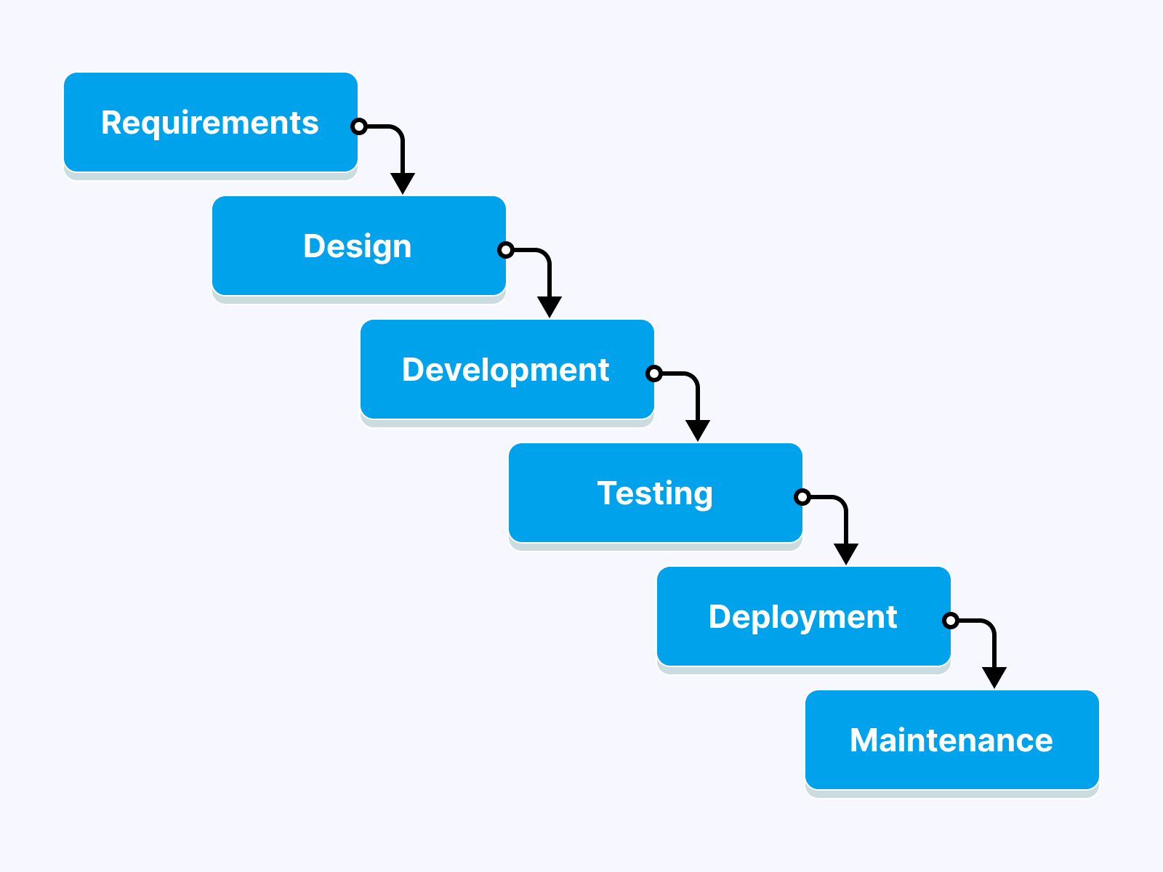

**Testing and Quality Assurance**

Detail the testing and quality assurance processes to ensure the reliability and performance of the telehealth software.

**Cost Estimate**

Breakdown of Development Costs

Itemize the development costs, including software development, testing, and deployment expenses.

**Licensing and Subscription Fees**

Specify the licensing and subscription models, along with associated fees.

**Maintenance and Support Costs**

Estimate ongoing maintenance and support costs for the telehealth software.